Name: ____________________________________________________ Date: _________________________________
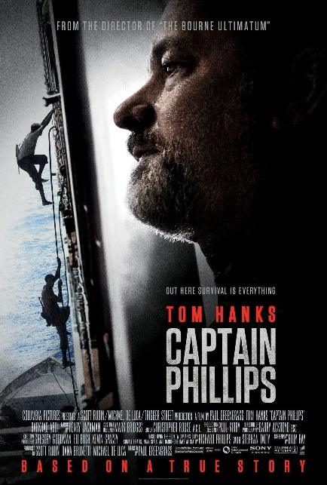
CAPTAIN PHILLIPS (SONY PICTURES)
1. Where does the story take place?

2. What is the ship’s cargo? What VALUE would the pirates see in it?

3. Identify the weapons used by:
The Maersk Alabama crew | The pirate crew

4. How does the Alabama crew attempt to stay safe from the pirate attack? Would you do things differently?

5. Why does Captain Phillips agree to a ‘prisoner swap’? Would you have done the same?

6. One of the pirates was eventually sentenced to 33 years in a U.S. prison. Does this seem fair? Why or why not?

7. Read the article provided from The Telegraph, a news report on the real events that the movie was based upon. Then, on a scale of 1-5, with 5 indicating the movie is completely historically accurate, give Captain Phillips a score for historical accuracy:
HISTORICAL ACCURACY RATING
i I I I I I I I i
1 2 3 4 5

I give CAPTAIN PHILLIPS a score of ________ out of 5 for historical accuracy.

8. Also referring to the article, complete the following chart while you read it:
Some things that the movie left out about this story…
Some things that surprised me…

Some things that I didn’t know before…

