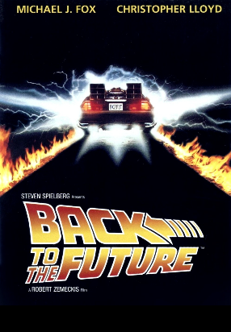
BACK TO THE FUTURE…life in the Fabulous Fifties

1. While watching the film, comment on the following:

Slang Terms | Culture – 1950’s (fads, fashion, music, lifestyles…) | Technology

2. After watching….
Based on the film, would you have liked living in the Fabulous Fifties? Write an opinion paragraph to explain your position, citing specific examples from the movie to support your answer.

