**Alternative Dispute Resolution (ADR)**

Copy the following diagram, and fill in the four methods of dispute resolution in a civil action appropriately:

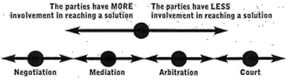



1. 2. 3. 4.

Methods of dispute resolution: (4)

1. _____________________________ 3. ___________________________

2. _____________________________ 4. ___________________________

**Alternative Dispute Resolution (ADR)**

Copy the following diagram, and fill in the four methods of dispute resolution in a civil action appropriately:





1. 2. 3. 4.

Methods of dispute resolution: (4)

1. Negotiation 3. Artibtation

2. Mediation 4. Litigation/Courts