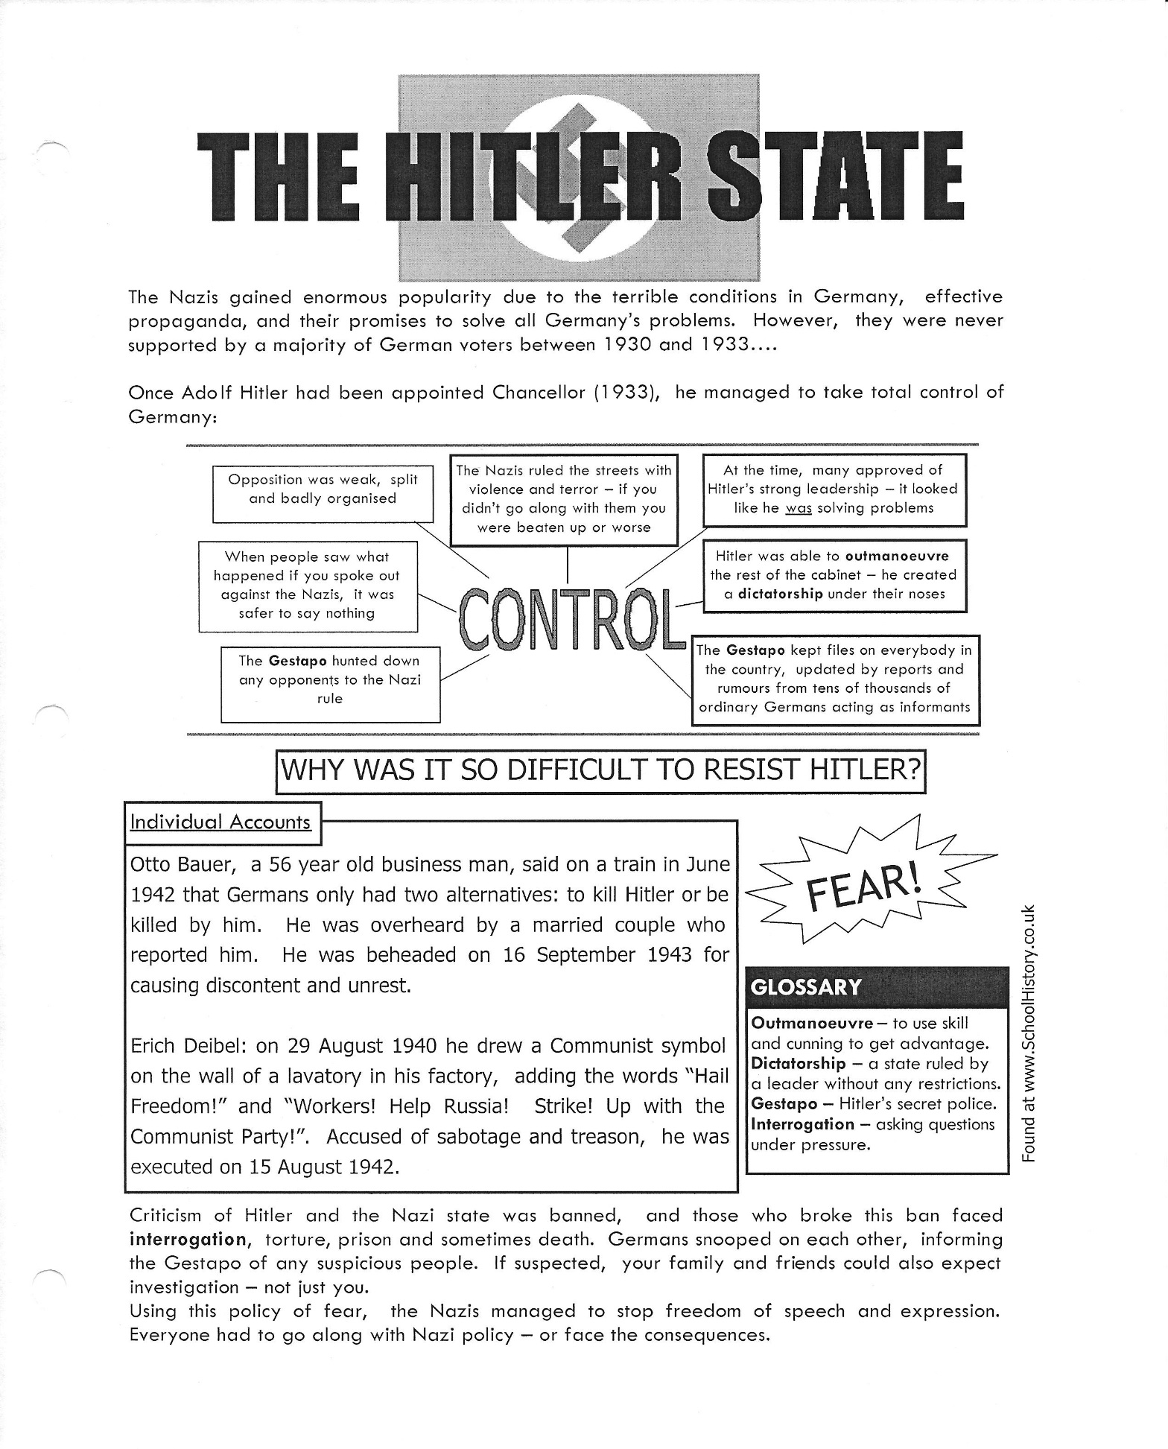

Questions
- What are the three reasons why the Nazis gained enormous popularity?
- When was Hitler appointed Chancellor?
- Copy out the spider diagram explaining how Hitler took control.
  - What or who were the Gestapo?
  - How did the Gestapo make sure Hitler faced no opposition?
  - How did the Gestapo get their information?
- What did Otto Bauer do to get beheaded?
  - What did Erich Deibel do to get executed?
  - Did these two people deserve to be killed? Explain your opinion.
- What did people who criticised the Nazis face? Even if you didn’t mind the consequences, why would you still be very unwilling to speak out against Hitler?
- What did the Nazis manage to do using their policy of fear?
You now have a choice. You can complete either of the next two questions. Either answer should be a full page hand-written response.
- Write an opinion paragraph under the title: Why it was so difficult to resist Hitler.
- Write an opinion paragraph and explain how Hitler was able to come to power.
For both answers, be sure you explain and cover the issues below:
- Conditions during the 1930s
- What the German people felt
- How Hitler explained Germany’s problems
- What Hitler promised
- How he used fear to gain control
A paragraph should contain some structure and particular elements like a topic sentence, several main points with supporting evidence and a conclusion which sums up the main points or ideas and it usually completes the topic.
ASSESSMENT GUIDE
Level 4 –Excellent  - Score 9 - 10 | Level 3 –Good  - Score 7 - 8 | Level 2 – Satisfactory  - Score 5 - 6 | Level 1 – Needs Improvement – Score 4
- Very clear  - Always refers to historical facts or evidence  - Minimal errors  - Analysis demonstrates high degree of depth and breadth of critical thinking | - Clear  - Mostly refers to historical facts or evidence  - Some errors  - Analysis demonstrates reasonable degree of depth and breadth of critical thinking | - Somewhat clear  - Sometimes refers to historical facts or evidence; opinion  - Many errors  - Analysis demonstrates some degree of depth and breadth of critical thinking | - Unclear  - Rarely refers to historical facts or evidence; opinionated  - Excessive errors  - Analysis demonstrates little or no degree of depth/breadth of critical thinking

